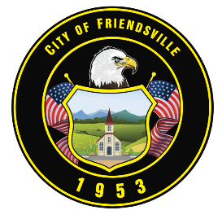

**IMMEDIATE RELEASE**  
**June 17, 2025**

City of Friendsville Clarifies Role in Upcoming Acadia Public Meeting

Friendsville, TN—The City of Friendsville would like to clarify the upcoming Public Meeting hosted by Acadia to discuss the proposed development of a behavioral health facility along Highway 321.

The City’s primary goal has been to facilitate open communication between Acadia and the residents of Friendsville. This meeting is intended to allow citizens to ask questions and express their concerns. While giving the opportunity to help the Planning Commission and Board of Commissioners make informed decisions.

It is important to note that the city was pushed to ensure this meeting occurred before the Planning Commission meeting on Tuesday, June 24. Had the City requested a different date for more notice, the meeting would not have occurred in time to inform the planning process.

The City has worked diligently to coordinate this event for the community's benefit, but it is important to note that the City does not have the authority to set or mandate the date of the meeting. The event's timing depended on Acadia's confirmation of their availability and decision to proceed with community engagement.

Once Acadia confirmed their willingness to host a public meeting, the city immediately contacted Friendsville First Baptist Church to secure a location. The church confirmed they could accommodate the meeting, pending a few logistical questions regarding space. Once these were addressed, the city quickly moved forward with a public Facebook post and mass text alert to ensure the public was informed.

As discussed during the June Commission Meeting, the city committed to providing public notice as soon as a date was confirmed, and we have honored that commitment.

The Public Meeting is scheduled as follows:

Date: Monday, June 23, 2025  
Time: 6:00 PM  
Location: Friendsville First Baptist Church  
403 N Farnum Street, Friendsville, TN 37737

The City of Friendsville encourages all residents to attend this meeting, ask questions, and stay engaged as the community considers this significant proposal.

City of Friendsville