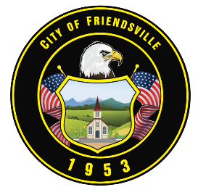

**IMMEDIATE RELEASE:**

**June 5, 2025**

**Update on Proposed Village Behavioral Health Development**

The City of Friendsville is committed to transparency and public involvement regarding the proposed Village Behavioral Health development. To ensure citizens have a meaningful opportunity to engage directly with project representatives, the city has contacted Acadia to request a dedicated public meeting focused solely on this project.

Acadia representatives have confirmed they will not attend tonight’s City Commission meeting. This decision was made in coordination with the City’s request to hold a separate public meeting where citizens, the Planning Commission, and the City Commission can all participate, ask questions, and be heard in a more appropriate setting.

This public meeting will be held at a larger location that comfortably accommodates the expected number of residents to ensure ample space for all attendees. Once the date, time, and location are confirmed, the city will share those details through all official communication channels.

Mayor Steven Cardwell and the Board of Commissioners thank the citizens of Friendsville for speaking up and staying engaged. Your input is valued, and we strongly encourage residents to attend Planning Commission and City Commission meetings regularly, not only when a specific issue arises but also to stay informed about the ongoing work in their community.

While Facebook and other social media platforms can help spread general information, the city encourages residents to rely on official sources and verified updates, especially regarding important topics such as zoning, ordinances, and development projects. Specific legal procedures govern these processes, and the City is fully committed to meeting all public notice and transparency requirements.

We will continue to keep the community informed as more information becomes available. Thank you for your continued involvement, interest, and support.

City of Friendsville